Light Proximity Switch Troubleshooting Guide

The Light Proximity Touch Switch Troubleshooting Guide covers troubleshooting and repair of the Light Proximity Switch (https://www.makersmakingchange.com/project/light-proximity-switch/). The most common failures are likely to include parts placed in backwards, typically the photodiodes, and main IC.

Tools needed for testing:
- Screwdriver
- Digital multimeter (do not use analog meters unless VTVM type)
- Small penlight type flashlight

Tools needed for repair:
- Wire cutters
- Soldering iron
- Solder
- Soldering pump or solder wick braid
- Two alligator clip jumper wires
- Black electrical tape (must be coloured black)

Checking for proper battery power
Set the multimeter to the 20 V Range. On the PCB, attach the negative lead to the gold colored battery tab closest to the LED. Attach the positive lead to the gold colored battery tab closest to the main IC chip . You should be able to measure a voltage of between 2.7V and 3.3V on your meter. If the battery is low, replace the battery.

Main troubleshooting
Photo DIODES:
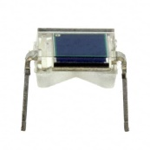
Begin by checking the main sensor photodiodes (small black squares on left and right of PCB). Set the multimeter to the 5V Range. Attach the positive lead of the multimeter to the lower (dot side) pin of the left photodiode, and the negative lead to the upper pin of the photodiode. Shine the penlight on the sensor, and you should see the voltage rise to above 0.2 volts. Repeat with the right side photodiode. If you don’t see a voltage increase the photodiode should be replaced. If the voltage reading shows negative (minus sign) the photodiode is in backwards, and should be reinstalled properly.

IC CHIP:
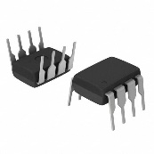
While shining the penlight on the left photodiode, and a small piece of electrical tape on the right photodiode, measure the voltage between pins 2 and 3 on the IC. make sure the negative lead of the multimeter is on pin 2. You should read a positive voltage in the 0.2 volt range. Now, place the negative lead of the multimeter on pin 4 of the IC, and the positive lead on pin 6. You should read a positive voltage between 2.5 and 3.2 volts. If the reading is correct, the LED should be lit. If the LED isn’t lit, it may be in backwards, or dead.

While shining the penlight on the right photodiode, and a small piece of electrical tape on the left photodiode, measure the voltage between pins 2 and 3 on the IC. make sure the negative lead of the multimeter is on pin 2. You should read a negative voltage in the 0.2 volt range. Now, place the negative lead of the multimeter on pin 4 of the IC, and the positive lead on pin 6. You should read a voltage close to 0 volts. If the reading is correct, the LED should be off.
PAGE 1 OF 3
Solid State relay (Mosfets):
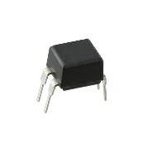
The Mosfets are the two black rectangles between the LED and the battery. While shining the penlight on the left photodiode, and a small piece of electrical tape on the right photodiode, confirm the LED is on. Measure the voltage across the two right side pins of each Mosfet (positive lead of the multimeter to pin marked with white dot) You should read a positive voltage between 2.5 and 3.2 volts, for each Mosfet.

Next, set your multimeter to CONTINUITY mode. Measure between each Mosfet drain pin (pin tab on left) and the source pin (pin without white dot on right) With the positive lead of the multimeter on the drain tab (on left side Mosfet). Make sure your meter beeps or shows less than 8 ohms. As part of each test, remove the tape and light, and turn the sensitivity fully counter-clockwise. The continuity reading should show “0” or off, (open circuit) when you do this.

Cable test
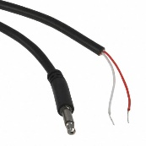
The final step, will be to confirm the cable isn’t open or shorted. With the Proximity switch off, (LED not lit), measure the continuity between solder joints J1 and J2 on the PCB (where the cord is soldered to the board) The continuity reading should show “0” or off. Now, measure continuity between the tip of the plug and solder joint J2. The reading should be “1” (or less than 4 ohms). Now, measure continuity between the metal sleeve of the plug (metal area behind tip) and solder joint J1. The reading should be “1” (or less than 4 ohms). If you get a zero reading testing J1 and J2, replace the cord.

Printed Circuit Board (main PCB):
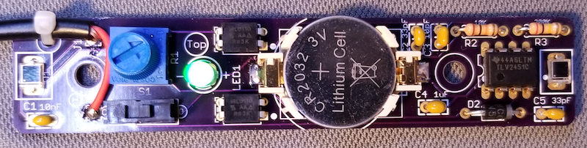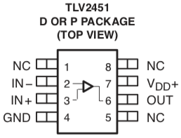

Schematic Diagram:
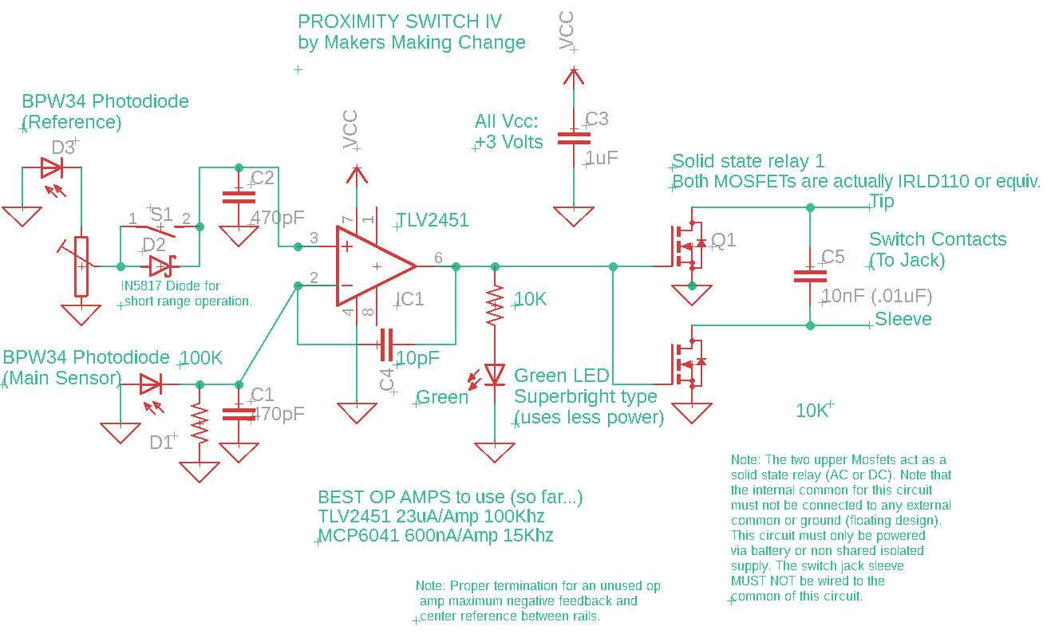
PAGE 2 OF 3

Parts List:
1 OP amp TLV2451 296-1889-5-ND
2 Mosfet IRLD110 IRLD110PBF-ND
2 Photodiode BPW34 475-1070-ND
1 DIODE SCHOTTKY 20V 1A DO41 1N5817-TPCT-ND
1 Superbright LED Green 5mm standard profile C566C-GFF-CX0Y0892CT-ND
1 Capacitor 10pF 6v 445-180508-1-ND
2 Capacitor 470 pf *399-9740-ND
1 Capacitor 10nF 50v *399-4148-ND
1 Capacitor 1uF 6v *399-9714-ND
1 Resistor 10k 1/4 watt *S10KQCT-ND
1 CR2032 battery holder BU2032SM-FH-GCT-ND
PAGE 3 OF 3

